Applies to: on-premises, cloud
This document describes how to configure the Validate Document plugin in Ephesoft Transact. These steps are intended for Transact administrators.
For information on the Validation screen for operators, refer to Reviewing and Validating Documents.

Overview
When a batch reaches the READY_FOR_VALIDATION state in Transact, it needs to be manually validated by an operator. Manual validation is performed on the Validation screen.
The Validate Document plugin controls various aspects of the Validation screen for operators, such as integration of external applications and the use of fuzzy search.

Prerequisites
To configure and use the VALIDATE_DOCUMENT plugin, the following configurations must be in place:
- You will need a batch class with a document type configured. For detailed steps, refer to Add New Document Type.
- Your document type should have at least one index field. For detailed steps, refer to Add New Index Field.
Note: The VALIDATE_DOCUMENT plugin is included in the Validate Document module by default.

Configure the Validate Document Plugin
This section provides information on how to configure the Validate Document plugin. This plugin only needs to be configured once per batch class.
To navigate to the plugin:
- From the Batch Class Management page, select and open your batch class.
- Go to Modules > Validate Document > VALIDATE_DOCUMENT.
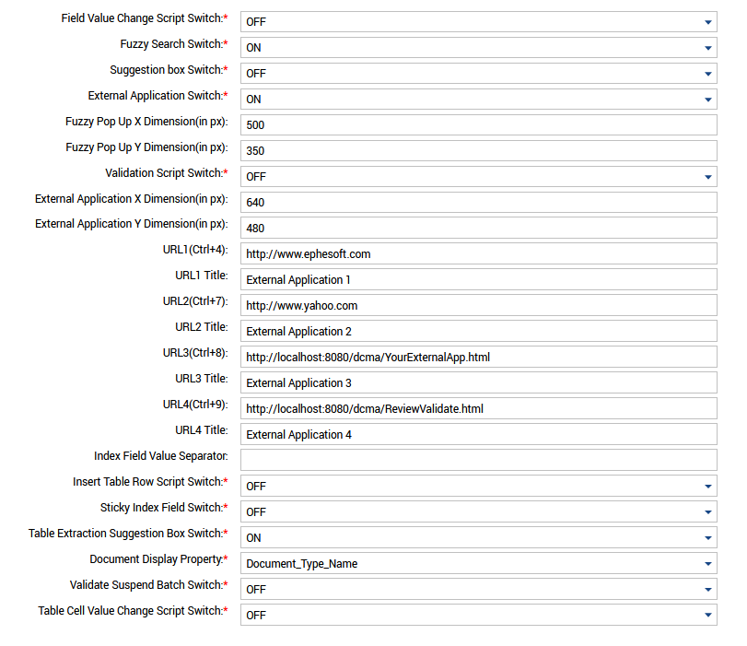
Figure 1. Validate Document Plugin
- Configure the plugin according to your workflow needs. Refer to the following table for more information on configurable properties.
Configurable Property | Options | Description
Field Value Change Script Switch | - ON  - OFF (default) | When set to ON, this switch causes the ScriptFieldValueChange.java script to run each time field values are changed.  Refer to the Scripting Guide for details.
Fuzzy Search Switch | - ON (default)  - OFF | When set to ON, this switch enables fuzzy search.  Refer to Fuzzy Search for details.
Suggestion box Switch | - ON  - OFF (default) | When set to ON, this switch enables a suggestion dropdown with alternate values for extracted fields.  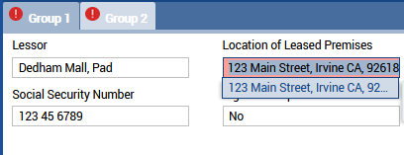
External Application Switch | - ON  - OFF (default) | When set to ON, this switch enables launching external applications from the Validation screen.  Refer to External Applications for details.
Fuzzy Pop Up X Dimension | N/A | This property specifies the width of the Fuzzy Search dialog box in pixels.
Fuzzy Pop Up Y Dimension | N/A | This property specifies the height of the Fuzzy Search dialog box in pixels.
Validation Script Switch | Options for Transact version 2022.1.01 and newer:  - ON - Trigger at Field Validation  - ON - Trigger when Document Validation Completes  - ON - Trigger when Batch Instance Validation Completes  - OFF (default) | This property specifies when ScriptValidation.java is run. These options determine when and how often the script is run.  - ON - Trigger at Field Validation: Launches the script each time a field is validated.  - ON - Trigger when Document Validation Completes: Launches the script once at the final validation of each document in the batch instance.  - ON - Trigger when Batch Instance Validation Completes: Launches the script once at the final validation of the entire batch instance.  - OFF (default): Does not launch the script.  Note the following:  - If upgrading from a version prior to Transact 2022.1.01, all batch classes that had this option set to ON are changed to ON - Trigger at Field Validation.  - For information about the validation script, see the Scripting Guide.
Validation Script Switch | Options prior to Transact version 2022.1.00.001:  - ON  - OFF | When set to ON, this switch causes ScriptValidation.java script to run whenever a batch is saved during Validation.
External Application X Dimension | N/A | This property specifies the width of the external application dialog box in pixels.
External Application Y Dimension | N/A | This property specifies the height of the external application dialog box in pixels.
URL1 (Ctrl+4)  URL2 (Ctrl+7)  URL3 (Ctrl+8)  URL4 (Ctrl+9) | N/A | These properties specify the URLs for each external application.  Refer to External Applications for details.
URL1 Title  URL2 Title  URL3 Title  URL4 Title | N/A | These properties specify the title for each external application. This title will display as the dialog box name when calling the external application.  Refer to External Applications for details.
Index Field Value Separator | N/A | This property specifies the string that should be used to separate values added when the operator holds Ctrl while selecting values on the preview image during Validation.  For example:  Note: The separator will only be added when holding Ctrl while clicking. Clicking on a value without holding Ctrl will replace the originally extracted content.
  Originally extracted value | ABC
  Index Field Value Separator | |
  Added value | XYZ
  Final value | ABC|XYZ
Insert Table Row Script Switch | - ON  - OFF (default) | When set to ON, this switch causes the ScriptNewTableRowInsert.java script to run when an operator adds a new row Table Validation.
Sticky Index Field Switch | - ON  - OFF (default) | When set to ON, this switch causes common index fields to retain their values when a document type is changed during Validation.
Table Extraction Suggestion Box Switch | - ON (default)  - OFF | When set to ON, this switch enables a suggestion dropdown with alternate values for extracted table fields.
Document Display Property | - Document_Type_Name (default)  - Document_Type_Desc | This property determines how the Document Type options will be displayed on the Validation screen.  - Document_Type_Name: Shows the document type name.  - Document_Type_Desc: Shows the document type description.  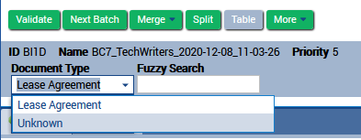
Validate Suspend Batch Switch | - ON  - OFF (default) | When set to ON, this switch enables you to suspend a batch during Validation.  Refer to Suspend Batch for details.
Table Cell Value Change Script Switch | - ON  - OFF (default) | When set to ON, this switch causes the ScriptTableCellValueChange.java script to run when an extracted table field is changed during Validation.  Refer to Trigger Field Value Change Script for Table Data Fields for details.

- When you are satisfied, click Apply.

Dependency
The VALIDATE_DOCUMENT plugin has a dependency on the following plugins:
- CREATE_DISPLAY_IMAGE: This plugin is part of the Page Process module, and is responsible for creating the preview images during Review and Validation.
- IMPORT_BATCH_FOLDER: This plugin is part of the Folder Import module, and is responsible for creating the BI folder and copying the single page tiff files into it.
Note: The VALIDATE_DOCUMENT plugin is marked as dependent on the CLOUD_HYPEREXTENDER plugin. This message appears in error. The Cloud HyperExtender plugin is not a dependency for any other plugins. Unless you plan to use the Cloud HyperExtender, click No when you see this message. This is a known issue.

Conclusion
This completes an overview of how to configure the Validate Document plugin in Ephesoft Transact.

